JUnit Basic Testing
Name: M. Sai Teja Email: saitejamuddapati@gmail.com
Exercise 1: Setting Up JUnit
Scenario
You need to set up JUnit in your Java project to start writing unit tests.
Steps
1. Create a new Java project in your IDE (e.g., IntelliJ IDEA, Eclipse).
2. Add JUnit dependency to your project using Maven (pom.xml).
3. Create a new test class in your project.
Java Code
pom.xml (Maven Dependency)
<project xmlns="http://maven.apache.org/POM/4.0.0"
xmlns:xsi="http://www.w3.org/2001/XMLSchema-instance"
xsi:schemaLocation="http://maven.apache.org/POM/4.0.0
http://maven.apache.org/xsd/maven-4.0.0.xsd">
<modelVersion>4.0.0</modelVersion>
<groupId>com.example</groupId>
<artifactId>JUnitBasicTesting</artifactId>
<version>1.0-SNAPSHOT</version>

<dependencies>
<dependency>
<groupId>junit</groupId>
<artifactId>junit</artifactId>
<version>4.13.2</version>
<scope>test</scope>
</dependency>
</dependencies>
</project>

MyFirstTest.java
package com.example;

import org.junit.Test;
import static org.junit.Assert.*;

public class MyFirstTest {

@Test
public void testMyFirstTest() {
int result = 2 + 3;
assertEquals(5, result);
}
}

Output
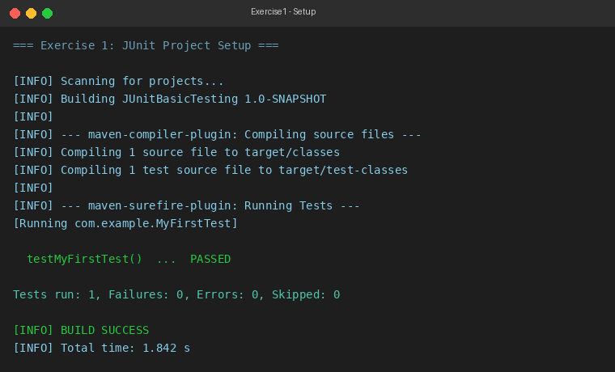
Exercise 2: Assertions in JUnit
Scenario
You need to use different assertions in JUnit to validate your test results.
Steps
1. Write tests using various JUnit assertions.
Java Code
AssertionsTest.java
package com.example;

import org.junit.Test;
import static org.junit.Assert.*;

public class AssertionsTest {

@Test
public void testAssertions() {
assertEquals(5, 2 + 3);
assertTrue(5 > 3);
assertFalse(5 < 3);
assertNull(null);
assertNotNull(new Object());
}
}

Output
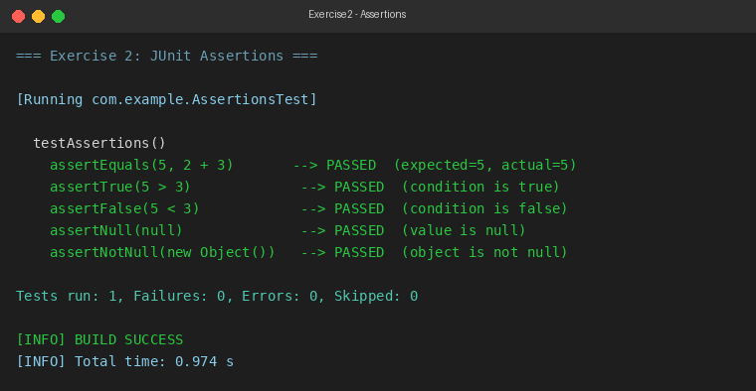
Exercise 3: Arrange-Act-Assert (AAA) Pattern, Test Fixtures, Setup and Teardown Methods in JUnit
Scenario
You need to organize your tests using the Arrange-Act-Assert (AAA) pattern and use setup and teardown methods.
Steps
1. Write tests using the AAA pattern.
2. Use @Before and @After annotations for setup and teardown methods.
Java Code
Calculator.java
package com.example;

public class Calculator {

public int add(int a, int b) {
return a + b;
}

public int subtract(int a, int b) {
return a - b;
}

public int multiply(int a, int b) {
return a * b;
}
}

CalculatorAAATest.java
package com.example;

import org.junit.After;
import org.junit.Before;
import org.junit.Test;
import static org.junit.Assert.*;

public class CalculatorAAATest {

private Calculator calculator;

@Before
public void setUp() {
calculator = new Calculator();
System.out.println("@Before setUp() --> Calculator instance created.");
}

@After
public void tearDown() {
calculator = null;
System.out.println("@After tearDown() --> Calculator instance destroyed.");
}

@Test
public void testAdd() {
int a = 10, b = 5;
int result = calculator.add(a, b);
assertEquals(15, result);
}

@Test
public void testSubtract() {
int a = 10, b = 5;
int result = calculator.subtract(a, b);
assertEquals(5, result);
}

@Test
public void testMultiply() {
int a = 10, b = 5;
int result = calculator.multiply(a, b);
assertEquals(50, result);
}
}

Output
